**Project Design Phase-II**

**Data Flow Diagram & User Stories**

|  |  |
| --- | --- |
| Date | 31 January 2025 |
| Team ID |  |
| Project Name | BookNest |
| Maximum Marks | 4 Marks |

**Data Flow Diagrams:**

**A Data Flow Diagram (DFD) is a structured graphical tool used to illustrate the movement of data within a system. It clearly represents how data is input, processed, stored, and output, providing a visual overview of the system’s functional flow. A well-designed DFD helps convey system requirements effectively by showing how information is transformed and where it resides throughout the process.**

Example: DFD Level 0 (Industry Standard)

**Example:** [**(Simplified)**](https://developer.ibm.com/patterns/visualize-unstructured-text/)

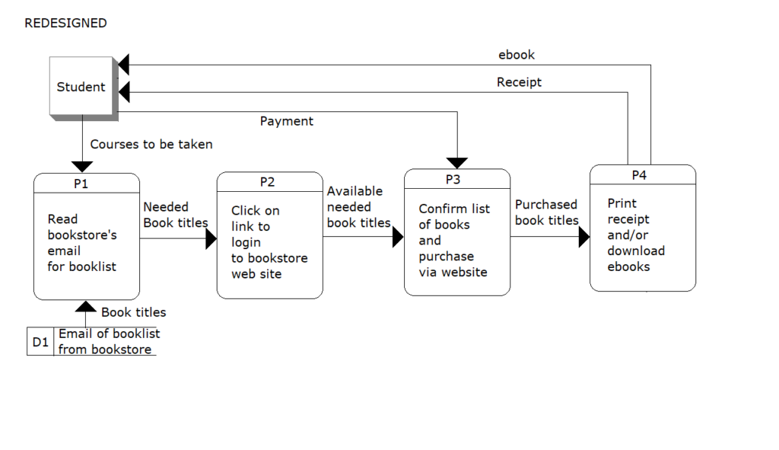

[This Photo](https://opentextbook.site/informationsystems2019/chapter/chapter-8-business-processes-information-systems-introduction/) by Unknown Author is licensed under [CC BY-NC](https://creativecommons.org/licenses/by-nc/3.0/)

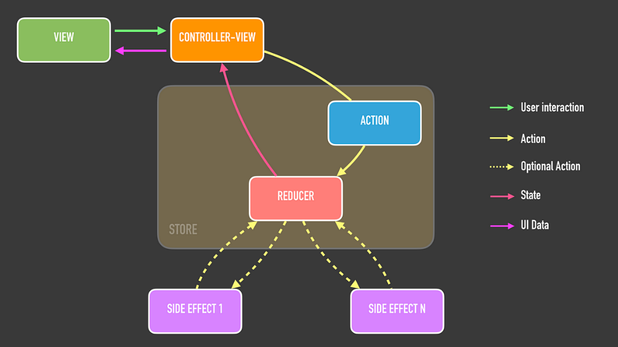

[This Photo](https://proandroiddev.com/unidirectional-data-flow-on-android-the-blog-post-part-1-cadcf88c72f5) by Unknown Author is licensed under [CC BY-SA](https://creativecommons.org/licenses/by-sa/3.0/)

**User Stories**

Use the below template to list all the user stories for the product.

| **User Type** | **Functional Requirement (Epic)** | **User Story Number** | **User Story / Task** | **Acceptance criteria** | **Priority** | **Release** |
| --- | --- | --- | --- | --- | --- | --- |
| Customer (Mobile user) | Registration | USN-1 | As a user, I want to sign up by providing my email and password, including a confirmation step | I can successfully register and reach my personal dashboard. | High | Sprint-1 |
|  |  | USN-2 | As a user, I want to receive an email confirmation after completing my registration. | I receive a verification email and can activate my account. | High | Sprint-1 |
|  |  | USN-3 | As a user, I want to sign up using my Facebook account. | I can access my dashboard via Facebook login. | Low | Sprint-2 |
|  |  | USN-4 | As a user, I want to register for the application using my Gmail account. | I can create and access my account via Gmail authentication. | Medium | Sprint-1 |
|  | Login | USN-5 | As a user, I want to log in by entering my registered email and password. | I can successfully access my account after login. | High | Sprint-1 |
|  | Dashboard |  |  |  |  |  |
| Customer (Web user) | Book Browsing | USN-7 | As a user, I want to explore books based on category, author, or price filters. | Books display accurately according to the selected filters. | High | Sprint-2 |
|  | Wishlist | USN-8 | As a user, I want to save books I’m interested in to a wishlist for future purchase.. | Selected books appear correctly in my wishlist section. | Medium | Sprint-3 |
|  | Cart & Checkout | USN-9 | . As a user, I want to add books to a shopping cart and proceed to place an order. | I can complete a purchase and receive an order confirmation. | High | Sprint-3 |
| Customer Care Executive | Ticket Handling | USN-10 | . As a support agent, I want to view and reply to customer complaints. | I can send responses and update the status of each ticket. | Medium | Sprint-4 |
| Administrator | User Management | USN-11 | As an admin, I want to manage user accounts and assign appropriate roles. | I can add, delete users, and assign or update roles successfully. | High | Sprint-4 |
|  | Inventory Management | USN-12 | . As an admin, I want to manage the book inventory by adding, editing, or removing listings. | Book catalog updates are visible in the public store. | High | Sprint-4 |
|  |  |  |  |  |  |  |
|  |  |  |  |  |  |  |